Levi George

03/27/2021

Prof. Amal Khalifa

CS 350: Programming Language Design

Homework 5: Ruby and Sub-Programs

1. What is the syntax for declaring parameters with default values?
   1. 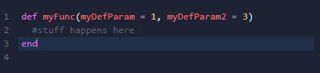
   2. **How are the default values used then the function is called?**
   3. The default values are used only when arguments are not passed. However, we must pass arguments in the proper order when we declare default parameters. Otherwise, we experience undefined behavior or logic errors.
2. How can functions be passed as arguments?
   1. You would first declare a function, and write the program to use the function. However, when you pass it, you must pass it as a symbol.
   2. 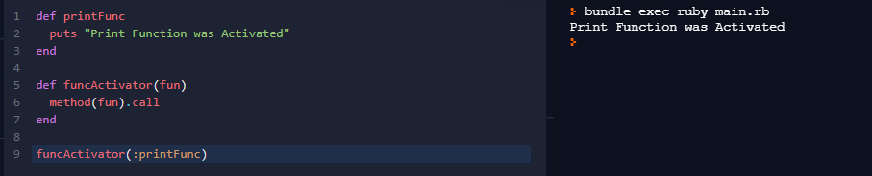
3. Define a simple recursive function and trace its call stack.
   1. 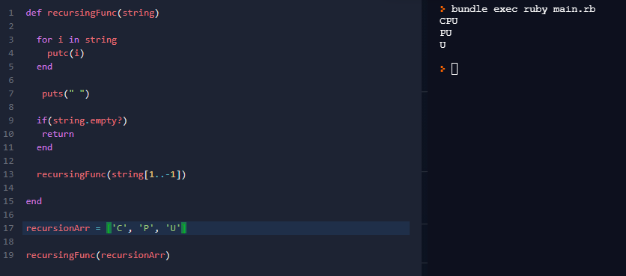
   2. 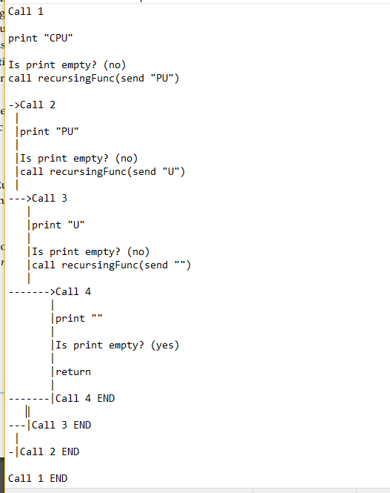
4. Is it possible to pass a variable number of parameters to a method? How?
   1. Yes, we use the *more keyword as an argument
   2. 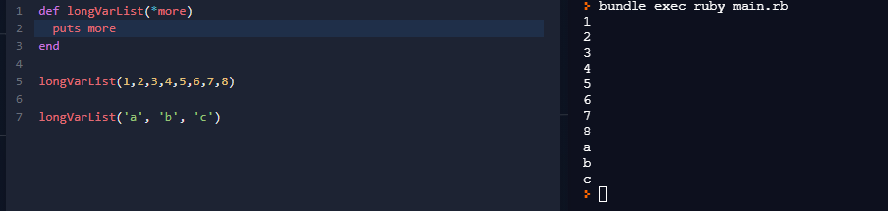
5. Can subprograms be overloaded? Why?
   1. Overloading is not directly supported, you could use different argument list lengths to implement some kind but not true overloading. This is because Ruby is dynamically typed, while overloading is only possible in statically typed languages.
6. Is there any support for generic subprograms? Why?
   1. No, for much the same reason that overloading is not supported.